**How to Cube Butter for Scones & Galettes**

Start by taking one stick of unsalted butter out of the refrigerator. It is best to use chilled butter at this point rather than room temperature butter because it is a little easier to handle. Cut off a piece that is five tablespoons. You can use the ruler on the paper as your guide.

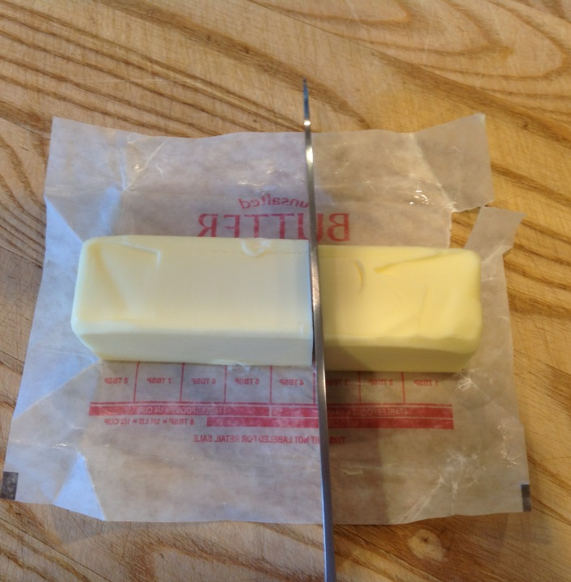

Then you are going to cut the five tablespoon piece in half lengthwise.

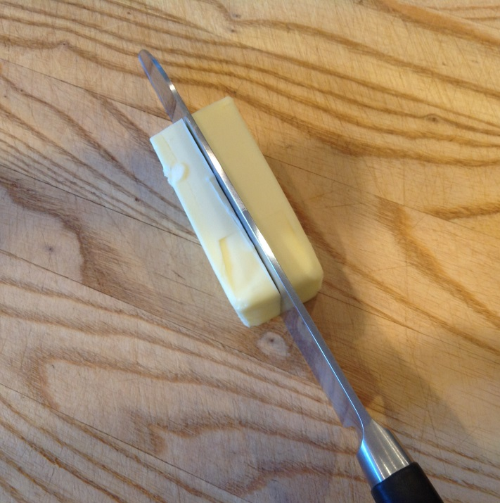

Then cut each half in half lengthwise again.

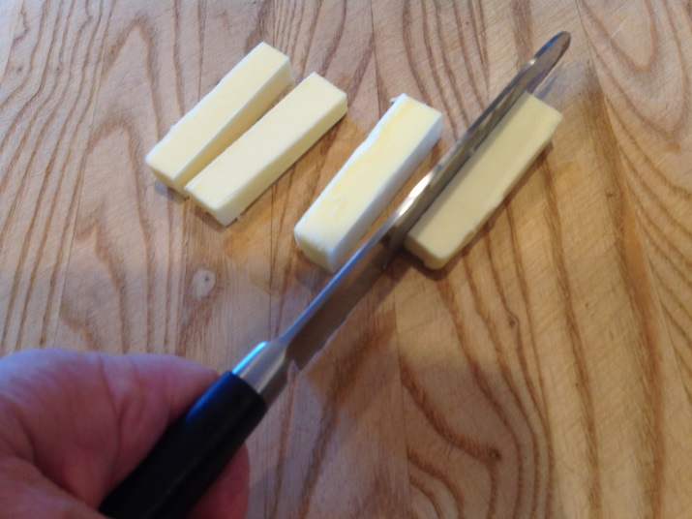

Then cut each of the long strips into small pieces. Each piece should be about the size of dice you use in board games or smaller.

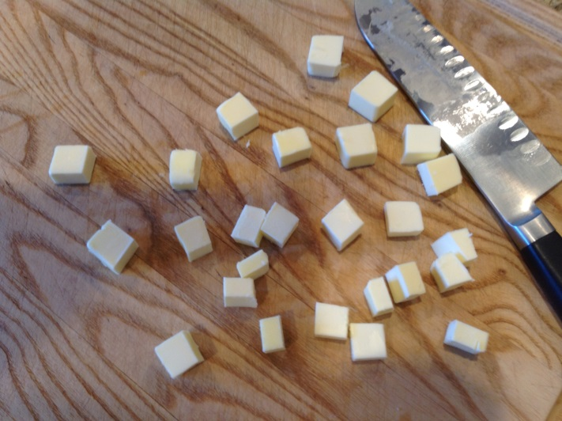

Then put about one teaspoon of flour into a small Ziploc bag. I don’t care what type of flour you use at this point but since we are going to use All-purpose Flour you may as well as use that in this step.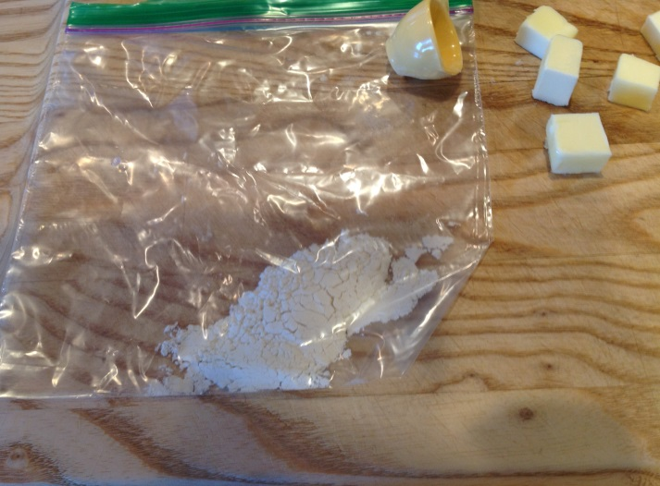

Now place the cut cubes of butter into the Ziploc bag with the flour and shake the bag to get the pieces of butter separated from each other and covered with a light dusting of flour.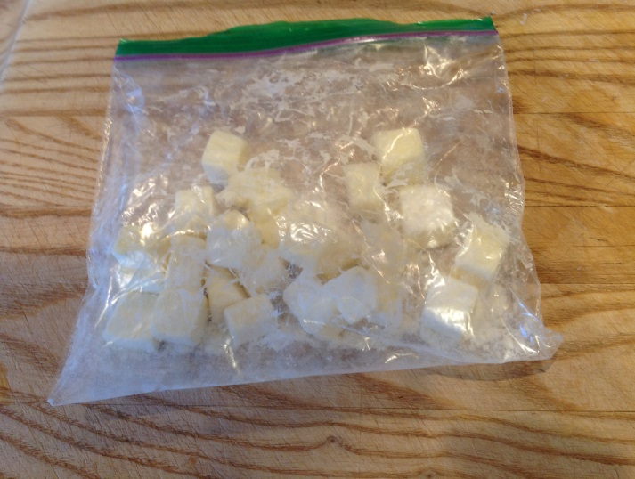

Place the bag of butter into your freezer and leave it there until you are told to remove it from the freezer during our class.